Cool Drinks Logo Identification using VGG16
Description:
A convolutional neural network is also known as a ConvNet, which is a kind of artificial neural network. A convolutional neural network has an input layer, an output layer, and various hidden layers. VGG16 is a type of CNN (Convolutional Neural Network) that is considered to be one of the best computer vision models to date. The creators of this model evaluated the networks and increased the depth using an architecture with very small (3 x 3) convolution filters, which showed a significant improvement on the prior-art configurations. They pushed the depth to 16-19 weight layers making it approx - 138 trainable parameters. The 16 in VGG16 refers to 16 layers that have weights. In VGG16 there are thirteen convolutional layers, five Max Pooling layers, and three Dense layers which sum up to 21 layers but it has only sixteen weight layers i.e., learnable parameters layer.VGG16 takes input tensor size as 224, 244 with 3 RGB channel.

Dataset:
The dataset consist of 13 images which have been augmented by changing different parameters to create a dataset of size 154 images.

Code:
import tensorflow as tf
import cv2
import random
import numpy as np
import matplotlib.pyplot as plt
import os
import tensorflow as tf
from tensorflow.keras.applications import *
from tensorflow.keras.models import *
from tensorflow.keras.layers import *
from tensorflow.keras.utils import load_img

lt = [cv2.ROTATE_180,cv2.ROTATE_90_COUNTERCLOCKWISE,cv2.ROTATE_90_CLOCKWISE]
def brightness(img):
value = random.uniform(0.5, 2)
hsv = cv2.cvtColor(img, cv2.COLOR_BGR2HSV)
hsv = np.array(hsv, dtype = np.float64)
hsv[:,:,1] = hsv[:,:,1]*value
hsv[:,:,1][hsv[:,:,1]>255] = 255
hsv[:,:,2] = hsv[:,:,2]*value
hsv[:,:,2][hsv[:,:,2]>255] = 255
hsv = np.array(hsv, dtype = np.uint8)
img = cv2.cvtColor(hsv, cv2.COLOR_HSV2BGR)
return img

from google.colab import drive
drive.mount('/content/drive')

items = os.listdir(directory)

classes=[]
count=0
images = []
labels=[]
for i in items:
i1 = 0
print(i)
classes.append(i)
path1 = f"{directory}/{i}"
a = random.randint(5,10)
img = cv2.imread(path1)
img = cv2.resize(img,(224,224))
k = i.split(".")[0]
cv2.imwrite(f"{resultant}\{k}{i1}.jpg",img)

i1+=1
while a!=0:
img = cv2.rotate(img,lt[random.randint(0,2)])
images.append(img)
cv2.imwrite(f"{resultant}\{k}{i1}.jpg",img)
i1+=1
labels.append(count)
if a%2==0:
img = brightness(img)
images.append(img)
cv2.imwrite(f"{resultant}\{k}{i1}.jpg",img)
i1+=1
labels.append(count)
a-=1
count+=1
images = np.array(images)
labels = np.array(labels)

images.shape

# change the model here for alternatives

model = VGG16(weights="imagenet")
for i in model.layers:
i.trainable = False

len(model.layers)

model.summary()

model2 = Sequential()

# adding layers from pre-trained model
for i in range(18):
model2.add(model.layers[i])

# adding custum layers
model2.add(Flatten())
model2.add(Dense(512,activation="relu"))
model2.add(Dense(128,activation="relu"))
model2.add(Dense(13,activation="Softmax"))

model2.summary()

import tensorflow as tf
class myCallback(tf.keras.callbacks.Callback):
def on_epoch_end(self, epoch, logs={}):
print("call")
if(logs.get('accuracy') > .99):
print("\nReached %2.2f%% accuracy, so stopping training!!" %(99))
self.model.stop_training = True
callbacks = myCallback()

# model1.summary()
model2.compile(optimizer="adam",loss="sparse_categorical_crossentropy",metrics=["accuracy"])
model2.fit(images,labels,epochs=100,callbacks=[callbacks])

model2.evaluate(images,labels)

def predict(i,model,labels):
path1 = f"{directory}/{i}"
img = cv2.imread(path1)
img = cv2.resize(img,(224,224))
a = np.argmax(model.predict(np.array([img])))
img = cv2.putText(img, labels[a], (25,25), cv2.FONT_HERSHEY_SIMPLEX,1, (225,225,0), 3, cv2.LINE_AA)
plt.imshow(img)

predict("pepsi.jpg",model2,classes)

Input:



Agumented Images:


Output:
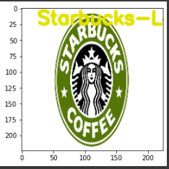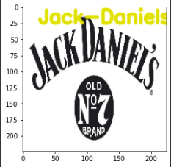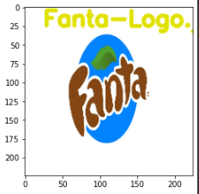

VideoLink:
https://drive.google.com/file/d/1_UgEE328pczQuAKf6IN8GROuqN4D0YGx/view?usp=drivesdk

